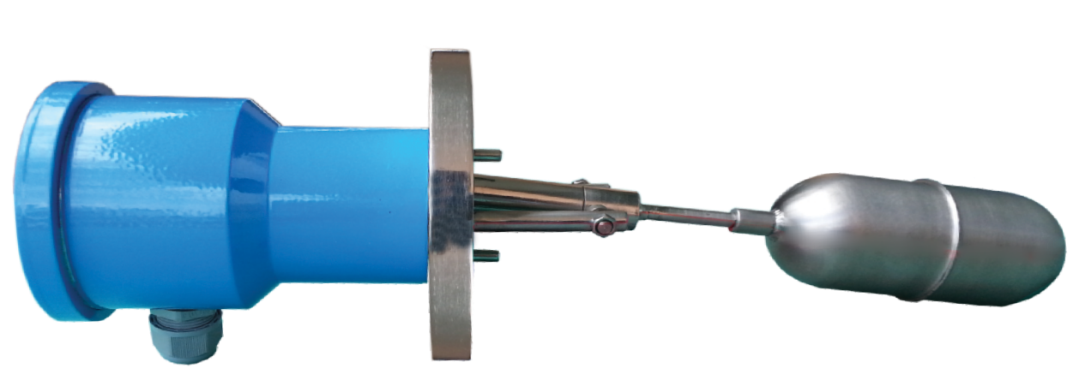
Description:
Side mounted level switch used to control liquid level in vessels containing corrosive or non-corrosive liquids. It is used to pump control, Alarm, valve control or level indication.
Principle
The Float lever Carries a permanent magnet which is repelled by similar magnet mounted in the switch housing. the magnet having the same pole directed towards each other are separated by a non-magnetic diaphragm. The gland less construction offer excellent sealing.
Construction
It consists of 3 main parts:
- Housing with Micro Switch
- Mounting Flange
- Float Assembly

Features
- Easy to install
- Reliable
- Available with different flange size
- Available in different MOC

Application
Water, Oil, Fuels, Chemical, Solvents, Syrup etc.,

Technical Specification
Switch Type : Micro Switch , SPDT
Switch Rating : 240 V AC, 5A
Enclosure : Weather Proof , Flame Proof
MOC : Cast Aluminum ,SS ,PP
Flange : SS 304 Also Available In ANSI ,BIS,DIN Standard Flange
Moc : SS304, SS316 ,PP
Float : Dia 50,60,75 , Non Standard
Max Temperature: 150 C (Hi Temperature on Request
Max Pressure : 20KG /CM( Higher Pressure On Request)
Manufactured By:

Levtron Instruments Pvt Ltd.
Office No 2, 1st floor, plot no 6, Pandhari Industrial estate, Shivane. Pune 411023,
Contact: 09579430012 / 9730042725 E-mail: sales@levtron.in ;
Website: www.Levtron.in

